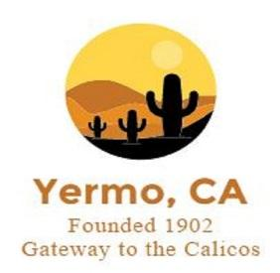 | YERMO COMMUNITY SERVICES DISTRICT  38315 McCormick Street, Post Office Box 206 Yermo, CA 92398-0206  Email: jbrakebillycfd@gmail.com  Web: www.yermocsd.org  PHONE: (760) 254-3408 CELL: (213) 407-9771 FAX (310) 564-1762 | 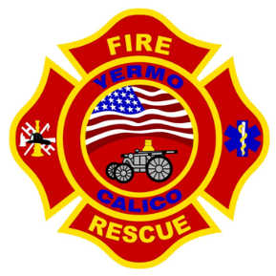
OFFICE OF THE FIRE CHIEF JAMES A. BRAKEBILL

Mutual Aid Agreement Between the Yermo-Calico and Daggett Fire Departments for Fire Protection & Emergency Services

This agreement, made on this day ______________between the Daggett Fire Department and Yermo/Calico Fire Department, aims to provide mutual aid benefits in fire prevention, protection of life and property from fire, and firefighting services. This includes emergency services such as basic medical support, basic life support, hazardous material containment and confinement, as well as special rescue events involving vehicular and water mishaps, and trench, building, and confined space extractions.
Agreed:
a. On request from a representative of the Yermo/Calico Fire Department, firefighting equipment and personnel from the Daggett Fire Department will be dispatched, when available, to any point within the area for which the Yermo/Calico Fire Department normally provides fire protection, as designated by the representative of the Yermo/Calico Fire Department.
b. On request from a representative of the Daggett Fire Department, firefighting equipment and personnel from the Yermo/Calico Fire Department will be dispatched, when available, to any point within the area for which the Daggett Fire Department normally provides fire protection, as designated by the representative of the Daggett Fire Department.
c. Assistance under this agreement is not mandatory, but the party must promptly inform the requesting department if they cannot provide help.
d. Any dispatch of equipment and personnel pursuant to this agreement is subject to the following conditions:
(1) Any request for aid under this agreement will specify the dispatch location for equipment and personnel. The representative will decide the equipment type and amount, along with the number of personnel.

(2) The responding fire department will report to the officer in charge at the location and follow their orders.
(3) The requesting fire department will release the responding fire department when its services are no longer required or if the responding fire department is needed in its primary fire protection area.

e. There will be no cost recovery actions taken against residents of the Daggett Community Services District for any emergency call attended by the Yermo/Calico Fire Department.
f. There will be no cost recovery actions taken against residents of the Yermo/Calico Community Services District for any emergency call attended by the Daggett Fire Department.
g. The Daggett Fire Department can respond to calls when the Yermo/Calico Fire Department is unavailable. When the Yermo/Calico Fire Department is in operation, the Daggett Fire Department may help with emergency calls, as dispatched by Cal Fire BDU ECC.
h. The Yermo/Calico Fire Department can respond to calls when Daggett Fire Department is unavailable. When the Daggett Fire Department is in operation, the Yermo/Calico Fire Department may help with emergency calls, as dispatched by Cal Fire BDU ECC.
i. The highest-ranking fire officer in the district will be the Incident Commander unless a more qualified person is assigned.
j. Each party hereby waives all claims against every other party for compensation for any loss, damage, injury, or death occurring because of the performance of this agreement, except those claims authorized under 15 U.S.C. 2210.
k. Chief fire officers and personnel from the fire departments of both parties to this agreement are encouraged to conduct reciprocal visits for guided familiarization tours, in accordance with local security requirements. Additionally, where feasible, they should jointly conduct pre-fire planning inspections and drills.
l. The Command Staff of the fire departments involved in this agreement are authorized and instructed to convene and develop detailed plans and operational procedures required to effectively execute this agreement. Such plans and procedures shall become effective upon ratification by the signatory parties.
m. All equipment used by the Yermo/Calico Fire Department in conducting this agreement will be owned by the Yermo/Calico Fire Department, and all personnel acting for the Yermo/Calico Fire Department under this agreement will be either employees or volunteer members of the Yermo/Calico Fire Department.
n. A conflict resolution process will be set up between the Daggett and Yermo/Calico Fire Departments. This procedure shall be conducted by the agency's Chief or an appointed representative as necessary to maintain a constructive working relationship.
(1) The agency Chief or their representative shall contact the other agency Chief or representative to initiate a meeting between both agencies to discuss the conflict.
(2) If the agencies are not satisfied with the decision of the conflict resolution meeting, either agency may exercise the termination procedure of this agreement.
o. This agreement will undergo review and update every 36 months or whenever modifications are necessary due to changing circumstances.
This agreement shall become effective upon the date hereof and remain in full force and effect until cancelled by mutual agreement of the parties hereto or by written notice by one party to the other party, giving thirty (30) days' notice of said cancellation.

Yermo Community Services District Daggett Community Services District
_______________________________ _________________________________
Clarissa Loehr Robert Whipple
Yermo CSD Board President Daggett CSD Board President

Date: __________________________ Date: _____________________________

_______________________________ __________________________________
James A. Brakebill Robert Roberson
Fire Chief Fire Chief
Yermo-Calico Fire Department Daggett Fire Department

Date: __________________________ Date: ______________________________

